**HardwareX article template**

*[Please fill in the template below and delete all instruction text in italics before submitting*.*]*

*GENERAL INFORMATION*

*HardwareX is an open access journal established to promote free and open source designing, building and customizing of scientific infrastructure (hardware). For more details on best practices for sharing open hardware see*[*http://www.oshwa.org/sharing-best-practices/*](http://www.oshwa.org/sharing-best-practices/)

**Title:***Sport Analyzer: Multi sensor device for data acquisition and visualization in sport performance evaluation and rehabilitation.*

**Authors: Xavier Cano-Ferrer and Albane Imbert**

**Affiliations: The Making Science Technology Platform, The Francis Crick Institute**

**Contact email:**[*xavier.cano-ferrer@crick.ac.uk*](mailto:xavier.cano-ferrer@crick.ac.uk) *,* [*Albane-Imbert@crick.ac.uk*](mailto:Albane-Imbert@crick.ac.uk)

**Abstract:** *[Max. 200 words. Remember that the abstract is what readers see first in electronic abstracting & indexing services. This is the advertisement of your article. Make it interesting, and easy to be understood. Be accurate and specific, keep it as brief as possible.*

Precise and reliable measurement of speed and force overtime are valuable attributes for a device

**Keywords:** *[At least 3 keywords. There is no limit on the no. of keywords you can list. Please remember that effective keywords should not repeat words appearing in your title, and should be neither too general nor too narrow.]*

**Specifications table** *[please fill in right-hand column of the table below]*

|  |  |
| --- | --- |
| Hardware name | *Sport Analyzer: Multi sensor device for data acquisition and visualization in sport science and rehabilitation.* |
| Subject area | *Please select the subject area most relevant to the original community for which this hardware was developed*   * Biomedical Engineering * Sport science * Physiotherapy * Biomechanics * Educational Tools and Open Source Alternatives to Existing Infrastructure |
| Hardware type | * Bio-instrumentation * Field measurements and sensors |
| Open Source License | *Please specify the open source license. For more details see the guide to authors.* |
| Cost of Hardware | *Approximate cost of hardware (complete breakdown will be included in the Bill of Materials).* |
| Source File Repository | *DOI URL to an approved source file repository:* [*OSF*](https://osf.io/wgk7q/wiki/home/)*,* [*Mendeley Data*](https://data.mendeley.com) *or* [*Zenodo*](https://doi.org/10.5281/zenodo.3356702)*. For example:* <http://doi.org/10.17605/OSF.IO/WGK7Q> |

1. **Hardware in context**

*[Include a short description of the hardware, putting into context of similar open hardware and proprietary equipment in the field.]*

*The two main platforms available to measure human movement associated magnitudes such as force, speed, power or Surface electromyography. The two product available are the Chronojump Boscosystem® and the Musclelab™. The First one is an open source software platform with several sensors (Contact platform, photo-cells, linear and rotary incremental encoder, load cell or race analyzer) that can be connected to the computer trough a PIC16F876A (Chronopic). The Musclelab™ device is an acquisition board with 8 Intelligent ports where different types of sensors can be connected (Linear Encoder, contact grid, force plate, load cell, accelerometer, sEMG, electrogoniometer or photo-cells.*

*Both devices are designed to operate with their respective software, the Chronojump Boscosystem® project has a very complete and free software platform with great tools for data analysis. The cost of the hardware ranges from (302,26€ VAT incl. 601,25€ VAT incl.) for the Load cell and the Linear encoder respectively. In the case of the Musclelab™ the software and hardware are commercial products with a cost of----------.*

*In this paper we present the first pocket sized and battery powered device that integrates some of the main and more popular sensors (Rotary and linear incremental encoders and load cells) with EMG recording on the same device with a high sampling frequency that enables the possibility to acquire the force or speed measurement with the sEMG signal simultaneously. It is also the first device with a small display that enables physiotherapists and trainers to evaluate a quantitative output of the patient/trainee performance in real time for any type of muscular contraction (Isometric, concentric, eccentric) and without the need of a computer. The device reduces substantially the costs associated to the measuring equipment and provides a wide range of commercially available options for sensors.*

*It also intends to familiarize and approach the health and sport professionals to the open source technology.*

*Another main difference between the presented device and the current more accessible commercially available option (Chronojump Boscosystem®) is the hardware integration on a single board instead of a board for each device and the hardware customization capabilities. This gives the users a new dimension to interact, understand and customize the hardware and the firmware embedded on the Teensy board.*

1. **Hardware description.**

*The device is based on the Teensy 3.2 development board and consists on a double layer PCB board which has 2 channels of surface electromyography (upgradable to 6 channels), one connection for an optical encoder, one connection for a S type load cell and one connection for an electrogoniometer. The device has a 2.8 inch TFT display for real time feedback and a SD card slot on the screen. The device is powered by a 9V battery and has a rocket ON/OFF switch and a pushbutton to change the displayed signal. It also can be powered, programmed and transfer data to the computer trough the Teensy 3.2 micro USB connector due to its very low power consumption (120 mA).*

*The device has a 3D printable case and a clear cover that can be laser cut in PMMA (3mm thickness).*

*Sport Analyzer opens a new field on hardware customized designs in sports science and rehabilitation in the same way that happens in other fields such as Neuroscience where there is an increasing number of hardware behavioural devices designed specifically to perform experiments in areas where there is not enough demand to justify commercial products.*

***Load cell***

*The Load cell is connected to the device by a female PCB mount RJ12 (6 wire) connector. The load cell wires (E+, E-, A+, A- and shield) must be soldered in a RJ12 male cable wires in the order described on the assembly instructions of the hardware repository. The analog signals of the load cell are processed by a 24-Bit Analog-to-Digital Converter (ADC) for Weigh Scales (AVIA Semiconductor HX711) and then sent to the Teensy 3.2 board as a digital signal (SCK and DATA) at a frequency of 80 Hz. There are a huge number of S load cells commercially available. The S load cell (https://www.amazon.co.uk/gp/product/B07X8PZ2HX/ref=ppx\_yo\_dt\_b\_asin\_title\_o02\_s00?ie=UTF8&psc=1) (Mass measuring range: 5kg-500kg, Input resistance: 350±10Ω, Sensitivity: 2.0mv/v, Output resistance: 350±5Ω) must be calibrated following the protocol published in the load cell assembly instructions and filling the load\_cell\_calibration.xls spreadsheet in order to get the linear equation that will be introduced on the Arduino code (Code file name). The Teensy 3.2 interfaces with the ADC trough the HX711 library for Arduino (https://github.com/bogde/HX711).*

***Incremental encoder***

*The linear incremental encoder is connected using a RJ12 female connector too. In the manual is described how to connect every wire from the encoder with the RJ12 cable. The linear optical encoder recommended is the CALT 1000 mm Linear Encoder (5-24V-NPN) (https://www.amazon.com/gp/product/B08H4TW7PV/ref=ppx\_yo\_dt\_b\_asin\_title\_o00\_s00?ie=UTF8&psc=1). The incremental encoder interfaces with the Teensy 3.2 using the highly optimized encoder library (https://github.com/PaulStoffregen/Encoder). The Encoder wire can be attached to a barbell, belt or strength training machine as described on the manual. The measured magnitude by the encoder is the linear displacement and its derivatives (linear velocity and acceleration). That enables sport and rehabilitation professionals to evaluate in real time the velocity or range of movement (ROM) of most exercises. Also enables researchers to calculate the power (P = Fv) considering the load displaced that can be body weight or an external weight.*

***Display***

*Both PCB have their header to attach the 2.8” TFT display (Adafruit product 1770). A display with 240x320 pixels with individual RGB pixel control with 4 white backlight LED. The signal can be visualized in the visualization-feedback mode. It also has a SD card slot.*

***3D printable case***

*There are two 3D printable cases available the Sport\_analyzer\_case.STL is intended to be used with the single board version and the Sport\_analyzer\_large\_case.STL is for the version with the EMG shield attached to it. The names of the signals are engraved on the case giving information to the user of which connector correspond to which sensor. Both cases have the same footprint in the same way that both PCB do, the only difference is the height and the extra holes for connectors.*

*The screen cover (Screen\_cover.DXF) can be laser cut in clear PMMA and attached with screws to any of both cases.*

***Battery***

***SD card***

***Computer acquisition software***

*The device can be used also to acquire data on your computer using the open source software PLX-DAQ (Parallax).*

*[Describe the hardware, highlighting the customization rather than the steps of the procedure. Highlight how it differs/which advantage it offers over pre-existing methods. For example, how could this hardware: be compared to other hardware in terms of cost or ease of use, be used in the development of further designs in a particular area, and so on.]*

*[Add 3-5 bulleted points to broadly explain to other researchers how the hardware could be potentially useful to them, for either standard or novel laboratory tasks, inside or outside of the original user community.]*

* …
* …
* …

1. **Design files**

*[The complete design files must be either uploaded to an approved online repository, uploaded at the time of submission on the online Elsevier submission interface as supplementary materials (CAD files, videos…), or included in the body of the manuscript (e.g. figures). The approved online repositories include* [*Mendeley Data*](https://data.mendeley.com/) *(*[*instructions*](https://doi.org/10.5281/zenodo.3346799)*), the*[*Open Science Framework*](https://osf.io/) *(*[*instructions*](https://osf.io/wgk7q/wiki/home/)*), and* [*Zenodo*](https://zenodo.org) *(*[*instructions*](https://doi.org/10.5281/zenodo.3346799)*).]*

*CAD files: Authors are encouraged to use free and open source software packages for creating the files. For CAD files,* [*OpenSCAD*](http://www.openscad.org/)*, [FreeCAD](http://www.freecadweb.org/" \t "_blank), or*[*Blender*](https://www.blender.org/)*are encouraged, but if not available source files from proprietary CAD packages such as Autocad or Solidworks and other drawing packages are acceptable.*

*3D printing. Supplementary files that facilitate the digital replication of the devices are encouraged. For example, STL files for 3-D printing components. We recommend uploading CAD files to the* [*NIH 3D Print Exchange*](http://3dprint.nih.gov/) *as Custom Labware and providing a link to the location.*

*Electronics: PCB layouts and other electronics design files can be uploaded to the* [*Open Hardware Repository*](http://www.ohwr.org/)*or other repositories .]*

*Software and firmware***:** *All software files used in the design and operation of the hardware should be included in the repository. Provide a description of software and firmware and use extensive comments in the code.*

**Design Files Summary** *[Please include a summary of all design files for your hardware by filling rows of the table below]*

|  |  |  |  |
| --- | --- | --- | --- |
| Design file name | File type | Open source license | Location of the file |
| *Sport Analyzer PCB.zip* | *Gerber* | *All designs must be submitted under an open hardware license. Enter the corresponding open source license for the file.* | *Enter a link to the online location or the sentence: "available with the article", as appropriate* |
| *Sport Analyzer PCB – EMG.zip* | *Gerber* |  |  |
| *Sport Analyzer PCB.brd* | Eagle |  |  |
| *Sport Analyzer PCB – EMG.sch* | Eagle |  |  |
| Enclosure | Step/STL |  |  |
| Battery cover | Step/STL |  |  |
| Front cover | Step/DXF |  |  |

*[For each design file listed in the summary above, include a short description of the file below (one or two sentences):]*

1. **Bill of Materials**

*[For a complex Bill of Materials, the complete Bill of Materials (editable spreadsheet file e.g., ODS file type or PDF file) can be uploaded in an open access online location such as the* [*Open Science Framework*](https://osf.io/)*repository. Include the link here. Alternatively, the Bill of Materials can be uploaded at the time of submission on the online Elsevier submission interface as supplementary material.]*

**Bill of Materials** *[Please include a summary of all components for your hardware by filling rows of the table below].*

|  |  |  |  |  |  |  |
| --- | --- | --- | --- | --- | --- | --- |
| Designator | Component | Number | Cost per unit -currency | Total cost -  currency | Source of materials | Material type |
| *To make it easy to tell which item in the Bill of Materials corresponds to which component in your design file(s), use matching designators in both places, or otherwise explain the correspondence.* | *Name of Component 1* | *Number of units* | *Cost per unit* | *Total cost* | *If possible include direct links to purchase component parts* | *Select from:*  *Metal*  *semi-conductor*  *Ceramic*  *Polymer*  *Biomaterial*  *Organic*  *Inorganic*  *Composite*  *Nanomaterial*  *Semiconductor*  *Non-specific*  *Other* |
|  | *Name of Component 2* |  |  |  |  |  |
|  |  |  |  |  |  |  |
|  |  |  |  |  |  |  |
|  |  |  |  |  |  |  |

*[Provide additional description of the Materials used here:]*

1. **Build Instructions** *[Provide detailed, step by step instructions for the construction of the reported hardware:*

* *Include all necessary information for reproducing the submitted hardware.*
* *Explain and, when possible, characterize design decisions. Including design alternatives if they exist.*
* *Use visual instructions such as schematics, images, and videos.*
* *Clearly reference design files and component parts described in the* **Design File Summary** *and* **Bill of Materials**.
* *Highlight potential safety concerns that may arise.]*

*5.1 RJ12 cable connections*

Except the EMG connectors, the load cell and the encoder are connected with the sport analyzer using RJ12 (6 wire) connections. In Fig. X is described which wires must be soldered with which ones to have a successful communication.

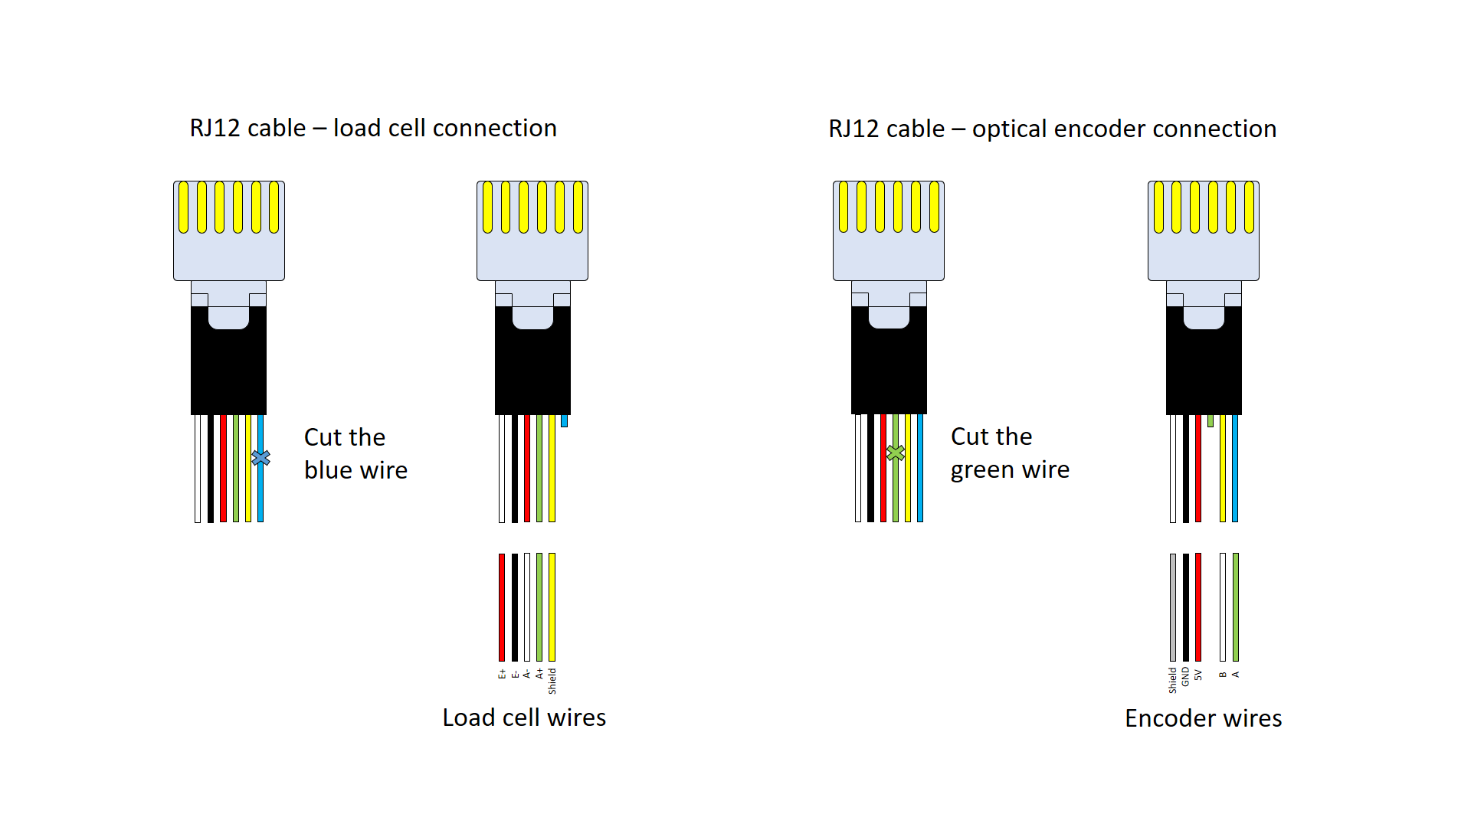

Fig. X. RJ12 cable connections with the different sensors.

*5.2.1 Load cell building process*

The only manufacturing process on the load cell side is the soldering of the RJ12 cable with the load cell cable. The RJ12 cable must be strip leaving approximately 30 cm of cable from the connector to the cut. Then solder can be applied on each of the wires of both sides Fig. X (1). A big heat shrink with bigger diameter than the cable and six smaller ones can be applied on the wires Fig. X (2). Then solder each of the wires one by one and apply heat on the small heat shrinks Fig. X (3). Now surround the five small wires with the big heat shrink and apply heat getting a continuous cable again Fig. X (5). The final step is to screw the M12 eye bolts on both sides of the load cell (6).

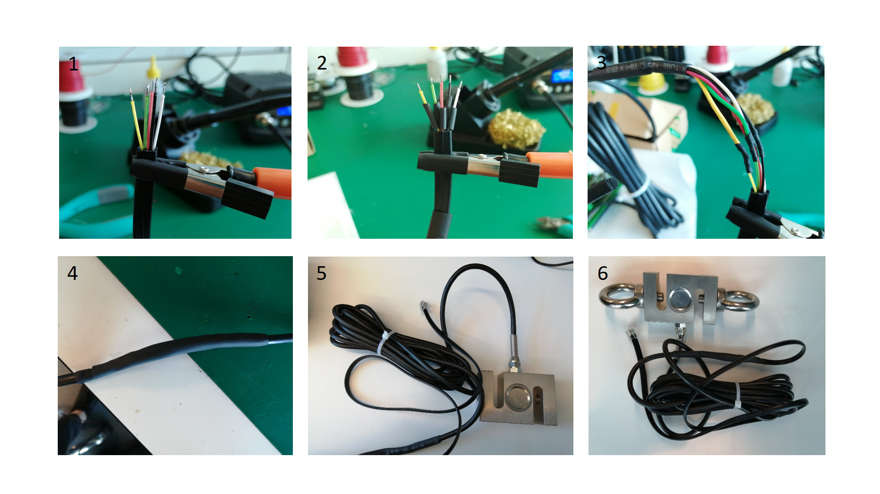

Fig. X. Load cell soldering and assembly process.

*5.2.2 Load cell calibration*

*5.3 Encoder building process*

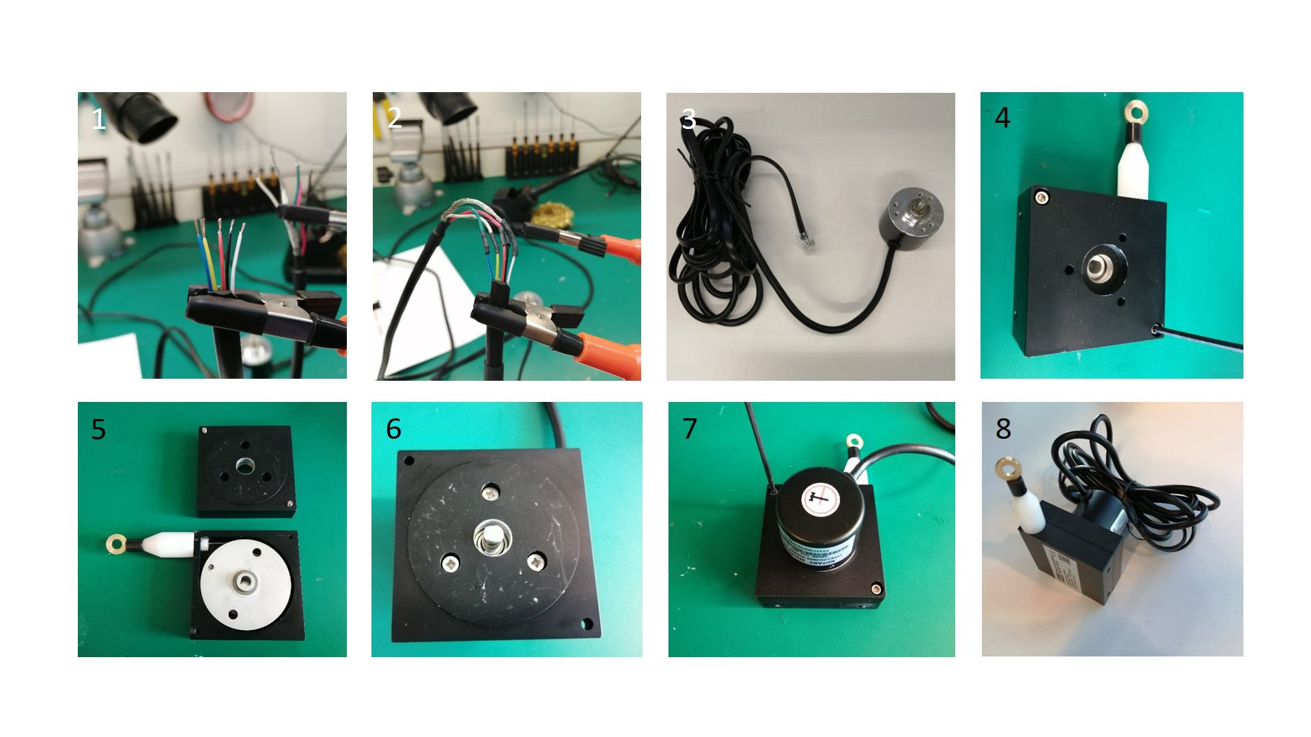

Fig. X. Linear encoder soldering and assembly process.

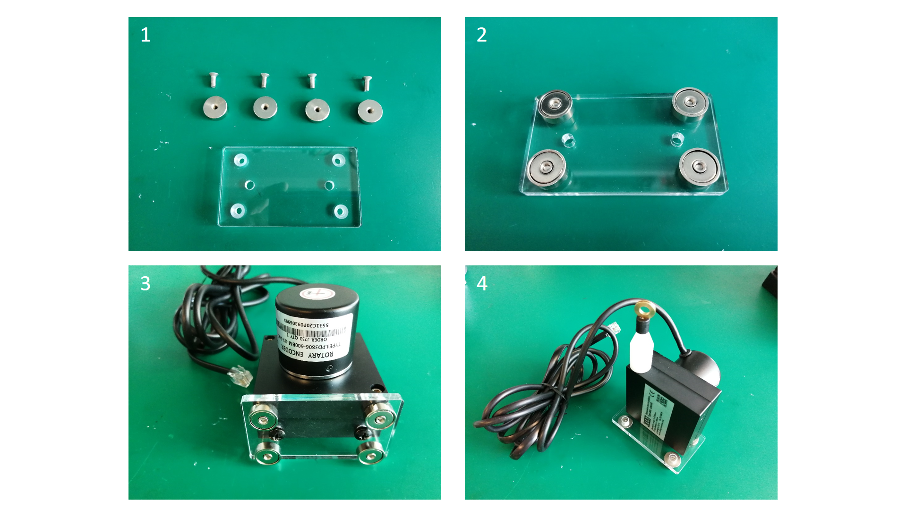

*5.4 Encoder calibration*

1. **Operation Instructions** *[Provide detailed instructions for the safe and proper operation of the hardware.*

* *Step-by-step operational instructions for operating the hardware.*
* *Use visual instructions as necessary.*
* *Highlight potential safety hazards.]*

1. **Validation and Characterization** *[Demonstrate the operation of the hardware and characterize its performance over relevant critical metrics:*

* *Demonstrate the use of the hardware for a relevant use case.*
* *If possible, characterize performance of the hardware over operational parameters.*
* *Create a bulleted list that describes the capabilities (and limitations) of the hardware. For example, consider descriptions of load, operation time, spin speed, coefficient of variation, accuracy, precision and etc.*

1. **Acknowledgements** *[List here those individuals who provided help during the research (e.g., providing language help, writing assistance or proof reading the article, etc.).]*

*Please also identify who provided financial support for the conduct of the research and/or preparation of the article and to briefly describe the role of the sponsor(s), if any, in study design; in the collection, analysis and interpretation of data; in the writing of the report; and in the decision to submit the article for publication. If the funding source(s) had no such involvement, then this should be stated.*

1. **Declaration of interest** *[a statement must be included even if there is no conflict of interest]*

*All authors must disclose any financial and personal relationships with other people or organizations that could inappropriately influence (bias) their work. Examples of potential conflicts of interest include employment, consultancies, stock ownership, honoraria, paid expert testimony, patent applications/registrations, and grants or other funding. Authors must disclose any interests in a summary declaration of interest statement in the manuscript file. If there are no interests to declare then please state this: 'Declarations of interest: none'. This summary statement will be ultimately published if the article is accepted.* [*More information*](http://service.elsevier.com/app/answers/detail/a_id/286/supporthub/publishing).

1. **Human and animal rights *[****If the work involves the use of human subjects, the author should ensure that the work described has been carried out in accordance with the appropriate ethical guidelines.*

*If the work involves the use of human subjects, the author should ensure that the work described has been carried out in accordance with* [*The Code of Ethics of the World Medical Association*](https://www.wma.net/policies-post/wma-declaration-of-helsinki-ethical-principles-for-medical-research-involving-human-subjects/) *(Declaration of Helsinki) for experiments involving humans;* [*Uniform Requirements for manuscripts submitted to Biomedical journals*](http://www.icmje.org)*. Authors should include a statement in the manuscript that informed consent was obtained for experimentation with human subjects. The privacy rights of human subjects must always be observed.*

*All animal experiments should comply with the* [*ARRIVE guidelines*](http://www.nc3rs.org.uk/page.asp?id=1357) *and should be carried out in accordance with the U.K. Animals (Scientific Procedures) Act, 1986 and associated guidelines,* [*EU Directive 2010/63/EU for animal experiments*](http://ec.europa.eu/environment/chemicals/lab_animals/legislation_en.htm)*, or the National Institutes of Health guide for the care and use of Laboratory animals (NIH Publications No. 8023, revised 1978) and the authors should clearly indicate in the manuscript that such guidelines have been followed.*

**References:** *[Include at least one reference, to the original publication of the hardware you customized. Include other references as required. Include references to put your device in context in the literature. For more information on the reference format in HardwareX please see the Guide for Authors at:* [*https://www.elsevier.com/journals/hardwarex/2468-0672/guide-for-authors*](https://www.elsevier.com/journals/hardwarex/2468-0672/guide-for-authors)*]*

\_\_\_\_\_\_\_\_\_\_\_\_\_\_\_\_\_\_\_\_\_\_\_\_\_\_\_\_\_\_\_\_\_\_\_\_\_\_\_\_\_\_\_\_\_\_\_\_\_\_\_\_\_\_\_\_\_\_\_\_\_\_\_\_\_\_\_\_\_\_\_\_\_\_\_\_\_\_\_\_\_\_\_\_\_

Additional Information for authors.(do not include these lines in your submission)

**Author manuscript checklist**

* HardwareX is a journal dedicated to the exhaustive and fully open source communication of advances in scientific infrastructure. Upon submission the author declares that all information necessary to reproduce the subject of the submission (e.g. bill of materials, build instructions, calibration procedures, source files, code, and safety considerations) is communicated in full and is accessible for use under an open source license.
* Is the subject of the submission under an open source license - as defined by the [Open Source Hardware definition](http://www.oshwa.org/definition/)?
* Can the hardware be reproduced with the details provided in the submission?
* Are all relevant design files available on Mendeley Data, the Open Science Framework, or Zenodo repositories, described in the Summary of Design Files document, and clearly documented? (e.g. descriptive file names, commented code, labeled images, etc.)
  + If in the Open Science Framework, the repository has be registered? [Instructions](https://osf.io/wgk7q/wiki/home/)
  + If in Zenodo, the repository is open access and is published? [Instructions](https://doi.org/10.5281/zenodo.3346799)
  + If in Mendeley Data, the repository is published or the sharable link was included in the additional information of the Editorial Submission interface? [Instructions](https://doi.org/10.5281/zenodo.3346799)
* Are visual instructions used when necessary?
* Is the utility of the hardware to the scientific community?
* Is the performance of the hardware adequately demonstrated and characterized?
* Are all potential safety concerns addressed?
* For more information on the article template consult the [Guide to Authors](https://www.elsevier.com/journals/hardwarex/2468-0672/guide-for-authors).